NASA VCLS ELaNa XX



EMI/EMC Spurious emissions compliance

# As requested by TriSept email on February 19, 2020

1. Approximately 80 seconds (see DITL)
2. Proprietary, using SPI, I2C, GPIO
3. SPI: 3.3V I2C: 3.3V GPIO: 3.5V
4. Duh
5. No cabling (other than RF); bus is stacked Samtec QSH/QTH 8mm connectors, 60 pins (see Samtec

2. The individual executing this attestation on behalf of their respective organization is an authorized signatory;

3. The organizations accept the condition of the spacecraft RadFxSat-2 and approve launch.

Date: August 3, 2018



Signature of Authorized Signatory for Vanderbilt University

**Brian D. Sierawski**

Printed Name of Authorized Signatory for Vanderbilt University

Date: July 26, 2018

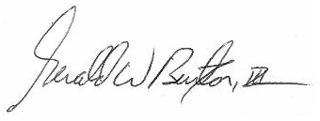

Signature of Authorized Signatory for AMSAT

**Gerald W. Buxton, III**

Printed Name of Authorized Signatory for AMSAT